**Cognitivity**

**High Level Design**

**Submitted by**: Ophir Katz

Mark Erlich

Ben Hunter

Guy Shemesh

Daniel Lyubin

Peer Sagiv

## Supervised by: Tanya Brokhman

**Table of Contents**

Abstract 3

1. Introduction 4

1.1 General Project Description 4

1.2 Programming Environment 4

2. Basic System Functionalities 4

3. Physical Framework 5

4. Software Implementation 5

4.1 Modules 5

4.2 Top-Level View 5

4.3 Main Menu 5

4.3.1 User Interface 5

4.3.2 Features 5

4.3.3 User Interface 5

5. References 5

# 

# Abstract

Creating cognitive tests for subjects can be tough work, more so when we want to consider different aspects of a cognitive process of a subject while completing a test. The project mainly focuses on the hardship of creating a test, in a purpose, of course, to eliminate the tedious parts of the job.

# Introduction

## General Project Description

Cognitivity is a platform for creating and conducting cognitive tests for subjects all around the world.

The platform is implemented as a web application which can be accessed anywhere.

## Programming Environment

1. Java technologies : Spring MVC, Hibernate.
2. MySQL.
3. Angular 4 with TypeScript.
4. HTML 5. CSS (bootstrap, or other styling frameworks and libraries).
5. Node.js.

# Basic System Functionalities

1. Login as an administrator/test manager.
2. Create a cognitive test.
3. Manage data objects such as tests, subject’s information, questions etc.
4. Conduct a test.
5. Measure time units during questions and tests.

# Physical Framework

After conversing with the server administrator in the faculty of industrial engineering, we gathered information about the servers in which our project will work.  
  
**Computational force:**  
The current servers are running on a ‘Vmware vsphere’ Digital framework, with the current computation power of 2 CPU, and 2 GB RAM memory.  
These limitations can be enhanced through a formal request to the server administrator, for up to 4 times its current computation power.  
According to the information we received from Rakefet, the current framework allows up to 50 users to use the server at once.   
With the data gathered from the server administrator, it seems like with a more efficient resource usage, the server should handle up to twice the amount of users using the same computational force. Since the bottlenecks with handling a server dedicated for conducting online tests is data transfer and data storage, an efficient way for handling the two issues is required in order to efficiently run the project on the given servers.  
  
**Security requirement:**The servers run on Linux OS, without any additional security measures other than the ones the OS supplies. The data transfer from, and out of the server is done using ‘https’ protocol – an encrypted data transfer protocol that encrypts that data before sending it through the web.  
Connection to the server farm is only possible through the Technion subnet, and only with the correct VPN key, that can be supplied by the server administrator.  
The current server farm does not support adding more security measures to the OS.  
Therefore, the current framework allows secure data transfer from the test subjects into the server, but in case of a malicious access to the server, the data in the server farm is not protected.

# Software Implementation

The core functionality of the system is capturing different interaction of the examinee during a test. The implementation of this functionality could be done by libraries and API’s in javascript.

## Modules

**Taking timestamps**

The point in tracking the time is to be as accurate as possible. So, to fulfill this target we can use the "performance" interface that delivers this ability. To support this claim, Google analytics, a service that provides tools for tracking user experience inside a business website, recommends using this API in their guides for time measurements.

The performance API is a JavaScript interface which provides access to related information to the current web page. An object of this type can be obtained by calling to Window.performance, which is a read only attribute.

The most helpful method of this interface for our project, is Performance.now(). This method returns the number of milliseconds elapsed since the page started loading. This is a very important attribute for our project, because this information could be used for the whole time measuring system. When we can gain this kind of information, it could be used for taking timestamps when a special events occurs, like a mouse click or a keyboard press (event handling of this kind will be explained in more detail later). Also, the timer is individual to each web page and we could also use this for our project.

So, to summarize this part, by using a simple and accurate interface in JavaScript we can take timestamps and to build the time measuring system.

**jQuery and event handling**

What is jQuery? This is a small, fast and feature-rich JavaScript library. It makes HTML document traversal and manipulation, event handling and more, very easy to use.

Advantages of jQuery:

· Very popular framework and there is a lot of information about it due to an extensive use by all the major companies – Google, Microsoft, IBM and so forth.

· As said before - easy to use.

· Supported by all major web browsers.

Adding jQuery is very simple and can be done by one simple line of code.

<**script** src="http://code.jquery.com/jquery.min.js" type="text/javascript"></**script>**

Another issue that came up is how to capture mouse clicks at any point on the screen, or in other words - how to capture the user's experience while they are filling in the form. The solution for this will be event handling via jQuery.

jQuery offers a lot of methods to register behaviors of the user when he interacts with the web browser. The two methods that will concern us the most are "click" - for capturing mouse clicks, and "keyup" - for capturing keyboard press.

We can capture the events on certain parts of the web page, and ignore some other parts. If we would like to capture mouse clicks in all parts of the web page we could use the line:

$('html').click(…)

Or if we want to capture a mouse click on a specific button or paragraph we could do it like this:

$('#element id').click(…)

*note: the same applies for a keyboard press only the function is keyup.

So, the input for the "click" and "keyup" function is a function that gets an event object. This function, which is referred to as the event handler, will be activated every time the specified event occurrs on the specified element. The event object is guaranteed to be passed to the event handler. This object holds numerous properties that could be helpful. Two of them are pageX and pageY which supply the specific coordinates of the event in the web page, this could be very useful and should be considered.

So, to summarize this part, jQuery is a very useful and easy library. Using the event handling mechanism could be very helpful and could be used to track the user's interaction inside the web page the whole time of the test. The event handling could be integrated with taking timestamps by calling performance.now when an event occurs.

## Top-Level View

The Project is implemented as a web application, so we will have backend modules and frontend modules.

**The Frontend:**

# Bootstrap

# Bootstrap is an open source toolkit for developing with HTML, CSS, and JS. Quickly prototype your ideas or build your entire app with our Sass variables and mixins, responsive grid system, extensive prebuilt components, and powerful plugins built on jQuery. Bootstrap allows you to build responsive, mobile-first projects on the web.

Angular

# General Explanation

Angular (Angular version 4) is a cross-platform, MVC development framework, developed and maintained by GoogleTM.

Angular applications can be developed for desktop browsers, mobile web and even native mobile and desktop applications.

The framework applies for the frontend aspect of your application, while giving you the freedom of implementing the backend in any way you wish.

In a way, Angular is a design pattern for web applications.

# Architecture Overview

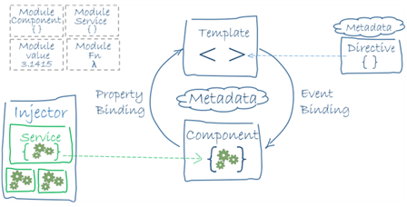

Figure 1: Architectural scheme

While it may seem that a website is built of html pages and serverside functionality, Angular’s Architectural view “breaks” the web application to different components that represent pieces of data that should be viewed as a single entity, hence improving cohesion and reducing coupling. Angular’s methodology is to encapsulate UI components for decreasing the dependencies between them to them minimum.

The basic parts of an Angular web app are as follows:

**Template and Component**

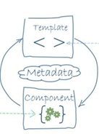

Figure 2: the VC in MVC

The View and Controller of the MVC design pattern. The Template is the UI as seen by the user, the regular HTML(5) components. The component is the controller. It holds the data that the template needs to show: lists, user data, etc. The component is an object containing the template’s state. The “Metadata” in Figure 2 is a class decorator that tells the component class which template it’s connected to, in what name should we call the component (a selector in HTML terminology)

Templates and components communicate in a “2-Way Binding”, The arrows in Figure 2. A template passes data to its component via “Event Binding” (the arrow directed from ‘template’ to ‘component’). User interactions with the UI trigger events which are functions declared in components’ classes. These events pass any data defined by the developer to the component’s object. For example, an Angular web app contains a registration form – a set of textboxes and a submit button. Each textbox is identified with a special identifier (which is a part of Angular’s syntax), and the form container (an HTML tag) identified with the same kind of identifier that combines all of the textboxes’ identifiers to a single value. The form also has an “onSubmit” event that passes data to the component.

Showing information on the screen is done with via “Property

Binding” (the arrow directed from ‘component’ to ‘template’). The information shown is a property of the component’s object. For example, we have a basic web app that shows a user’s first and last name, and the data is fetched from a server.

The names are stored in two variables, firstName and lastName which contain the names respectively. Both of these variables are properties of the class. In the template, we will show the names inside any HTML tag that shows text, an h1 tag for example. The names will be displayed with the following syntax:

<h1> {{ firstName }} {{ lastName }} </h1>

If we had a form that changes these names (a form with a structure similar to the previous example), when we’ll submit it, the names will change (after submission).

There’s also a way to dynamically change information presented on the screen as we edit the property (with a textbox bound to it, for example), called ngModel. With this feature, a property is both an input and an output. The figure bellow demonstrates and summarizes the types of data binding featured in Angular.

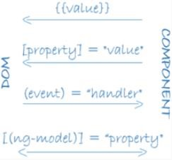

Figure 3. (DOM=HTML)

**Services**

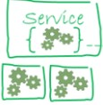

A service is a class that contains a single logical behavior of the application. It can implement anything that’s needed for the app, from talking with a database or serverside program, to getting pictures from websites via HTTP requests. Services encapsulate the (ugly) implementations of backend behaviors, while letting the components talk with the backend via interfaces they provide.

Remember the gear drawings in Figure 2? It’s not coincidental, because components include services’ instances. The use of services dramatically improves the development process and provides code reuse, encapsulation, etc. A component *never* calls directly to backend functionality. Instead, he calls a service’s functionality.

**Modules**

Modules are classes that provide large functionality. There is usually one module that contains the developer’s components (UI), services, but it can contain only functions and services that serve the same purpose and should logically be together under the same module. For example, there is a module called BrowserModule that oversees rendering the web app on the browser.

The first component that’s loaded is a default component called AppComponent (can be named however desired) and it’s the root component. It can contain components which contain other components, and so on. Intuitively, the web application’s structure resembles a tree, where a node is a component and a child node is a component nested in another component (illustrated in Figure 4).

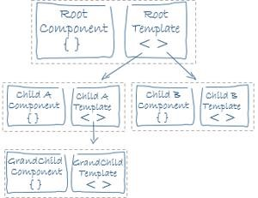

Figure 4: Component nesting tree

# Advantages

• Modular development

• Component encapsulation

• Component and code reusability

• Use of an object oriented (both statically and dynamically typed) language, which allows declarative programming

• Developed by GoogleTM and an open source project, so it’s supported and maintained (It won’t go away anytime soon)

• Deployed on a server quite easily

• Can run on anything - browsers, mobiles, tablets • Easy testing, because of modularity.

# Disadvantages

• Clientside development only. No framework for a serverside development, so without a database which provides a module that integrates with Angular, developing a custom DB can be tough and quite a headache, but with proper development it will be a one time headache

• Since Angular doesn’t have a common syntax, there is a learning curve. But once again, it’s a one time headache Angular is great. Use it.

**Sources:**

Angular Documentation:<https://angular.io/guide/architecture>

**POC for Our Project**[https://www.codeproject.com/Articles/860024/Quiz-Application-inAngularJs](https://www.codeproject.com/Articles/860024/Quiz-Application-in-AngularJs)

# TypeScript vs. JavaScript

TypeScript is a superset of JavaScript, meaning TS provides additional functionality to JS. TS eventually compiles to JS, so you can write JS code in a TS file.

**Pros:**

• **Provides optional static typing and static type checking, thus preventing errors in early development stages.**

• **Added OOP principles and features – classes, interfaces, inheritance, private/public members, etc.**

• **Easily understandable by javascript developers, especially by programmers who are familiar with OOP concepts.**

• **Comfortable, modular and organized development for large projects.**

**Cons:**

• **Javascript’s cons, except the problems TS solves.**

**The Backend:**

As the most commonly used language for backend in web applications is **Java**, we chose to use it for our implementation of the backend logic.

**Java technologies for developing the backend side:**

Spring Web MVC (or just Spring MVC) is the original web framework built on the Servlet API and included in the Spring Framework from the very beginning. The Java Servlet API is just a standard for implementing Java classes that respond to requests. It is designed in a way that web based application (which naturally involve a lot of request based web page changes) could use it very easily. The Spring MVC framework allows for extensive configurations, either using the web.xml file or even via the Java code. Moreover, the MVC module provides default configuration (that can be changed easily) suitable for most applications. Spring offers a neat way to define REST clients for transferring data between the web application and the server side (for various purposes, such as storing data, or handling web pages requests). Spring MVC also offers a very comfortable way to test the entire backend, using Mocks, which is incredibly convenient for testing Java classes.

**Spring’s modularity for use with AngularJS:**

First of all, as stated before, Spring is entirely modular. This makes it possible (and easy) to program the backend logic without regard to the web technology used for the UI.

You can define controllers, adapters and more objects to implement logic of the backend, all in Java, while the configuration of the web technology used, is only done in the xml configuration files. For instance, declaring that a certain service of the UI is implemented in a file called service.js (or service.ts), can be easily be done by inserting a <script> tag in the corresponding .jsp file (like homepage.jsp, for example).

**Integrating with Angular’s services** is also easily done: Spring MVC defines a controller, which defines interfaces for conversing with a frontend, and Angular can define how to use these interfaces when implementing different types of services, such as pulling data from a data server (which is done via the server side), or requesting a web page, and so on… The RESTful services Angular calls are also integrated in the Spring framework, so it makes for an even easier development (because the design is already implemented).

The way it is done is by defining interfaces and then implementing these interfaces as services to offer from within the controller class. The controller is accessed from Angular.

**Learning curve with Spring MVC:**

As stated, this is just a Java library, so it is written in only Java, using some configurable content in xml. So, All we really need to know is Java, and to read a lot on the framework (it has alot of features, but what’s good is that we probably won’t use them all).

**Pro’s**

* Spring MVC is FREE!
* It is highly used in building web applications. Actually, it is the most used in Java, grabbing over 40% of the market.
* It is written in only Java - easy to learn + all of the team mates already know a portion of Java (as a prerequisite to this course).
* It has a lot of guide online, and a bunch of examples for building web applications, even using AngularJS for frontend.
* As the most used library out there, it is very unlikely that it will stop being supported. Since it is also open source - that is probably impossible.

**Java’s way to interact with a SQL data server:**

Since we are definitely using a SQL data server, Hibernate ORM is a great option:

**Hibernate ORM** (Hibernate in short) is an object-relational mapping tool for the Java programming language. It provides a framework for mapping an object-oriented domain model to a relational database.

The ORM model is THE way to use any relational data servers, for creating data, and reading from it. It interacts with such servers using JDBC ( = Java Database Connectivity is an application programming interface for the programming language Java, which defines how a client may access a database. It is Java based data access technology and used for Java database connectivity).

Hibernate was designed to work in an application server cluster and deliver a highly scalable architecture, which answers, in theory, any questions about number of users the application will have, regarding access to the data server.

Just like Spring, Hibernate is highly configurable.

Hibernate is well known for its excellent stability and quality, proven by the acceptance and use by tens of thousands of Java developers, which means it will be supported for a long time.

Hibernate is database agnostic. It doesn’t care if you use Oracle, SQL Server, MySQL, or about a dozen other relational databases. This means that without regard to the database we will use, Hibernate will be good with it. Specifically, as we will most likely be using a kind of SQL server, Hibernate is perfect.

**Configuring Hibernate to work with Spring:**

This configuration is done via just xml config file in the project directories. It is easy, and does not need further dependencies.

**Configuring Hibernate to work with the data server:**

This configuration is done via just xml config file in the project directories. It is easy, and does not need further dependencies. We also need to write a sql script file to define the tables in our database.

**To summarize:**

There really is no fault with using the Hibernate service. Both it, and the JDBC are highly used for accessing different types of data servers, and the only thing we need to do is to configure the correct one with the system, and implement the objects about which we want to converse with the server.

**Database management system:**

In the project we are going to use MySQL Community Edition as our Database management system. MySQL Community Edition is an open source software (given with GPL license) it is known for its speed over other Database management systems and its simplicity, has GUI, and supports a wide range of languages (full data and other compression data on other Systems in separate report).  
**Specification:**

1. Max Database size: no limit.
2. Max number of Databases: no limit.
3. Max number of tables: no limit (though the storage engine might limit the number of tables).
4. Max number of columns: 4096.

Pros:

1. Supports ACID (Atomicity, Concurrency, Isolation, Durability).
2. Easy to use and install.
3. Have GUI.
4. Considered Secure.
5. Faster than other database management systems.
6. Very popular (so there's a big community online).
7. Free

Cons:

1. Slow development of new versions.
2. There are rumors that the software might be unstable over a certain load (though it probably was in earlier versions) .

### Features

1. Login as an administrator/test manager.
2. Create a cognitive test.
3. Manage data objects such as:
   1. Information about different tests,
   2. Information about a subject
   3. different types of questions: open questions and multiple choice questions.
4. Conducting a test by a subject.
5. Measuring how much time an examinee spends in a specific question.
6. Measuring how much time takes to an examinee finish the test.
7. Measuring how many mouse clicks an examinee made in a single question.
8. Show to a specific examinee the amount of time that remained for the whole test.
9. Show to a specific examinee the amount of time that remained to a specific question.
10. Compute the number of times that the examinee changed his answer.
11. Compute the amount of time that took the examinee answer the right question.

### User Interface and features

**Overview of GUI entities**

**Projects**

**Purpose:**

Each “project” will present a different “whole”.

When a customer builds a new survey – he creates a new “project”.

Just like a coding project.

**Blocks**

**Purpose:**

In every project, we’ll hold a list of blocks. Each block will hold a bag of ordered questions.

The blocks will allow a user to save a successful set of question along with their options and settings.

**Questions**

**Purpose:**

In every block we hold an infinite list of question.

Every question will provide the maximum level of customization.

Each question will have the following basic set of setting:

· Type of question (multiple choice, graphic, etc).

· Position of answers.

· The question’s text position.

· Ordinal value according to the order in the block.

Note that the user should be able to copy an existing set of question’s setting.

**Overview of the manager’s screens**

“manager” = the user that builds the tests.

**The *Preview* mode**

**Purpose:**

To allow the user to see the survey the same way the subject will see it, without generating new raw data.

**The analysis view**

**Purpose:**

This view will provide the users possibility to examine all recorder data.

Along with some graphical view that’ll be appealing to the eye.

**The survey flow view**

**Purpose:**

This view will allow the user to observe his survey as a whole, and get comfortable summary of his survey structure.

**Overview of the subject’s screens**

“subject” = answers the survey and generates raw data.

**The registration form**

**Purpose:**

Each subject that answers the survey will also fill a registration form.

The data from those forms will be collected and presented to the manager of the system for further analysis.

**The survey screen**

**Purpose:**

Our main screen – the one that the subject sees while answering the survey.

Note that the screen is not “static”, and contains different questions ordered by the questions and blocks structure.

It’s important to state that this screen will also contain optional “triggers” which will be defined by the manager while creating the questions.

**Overview of graphical features – manager’s view**

***The following section will describe the optimal structure of the graphical interface, along with examples from Qualtrics* and hand written drafts.**

***Please keep in mind that the images are just for conception understanding purposes.***

**The “projects view” page:**

· Each project will be viewed as a record.

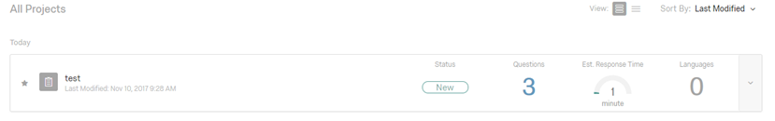For each project record we’ll present the following info:

· Status (New \ Active \ Finished).

· Questions (number of them).

· Filled copies (by different users).

· Last modified date.

· Last date the survey was filled.

**Required features –**

· Change the ordering of the presented projects by:

o Last modified

o Last answered

o Number of filled copies

o Number of questions

**Visual draft:**

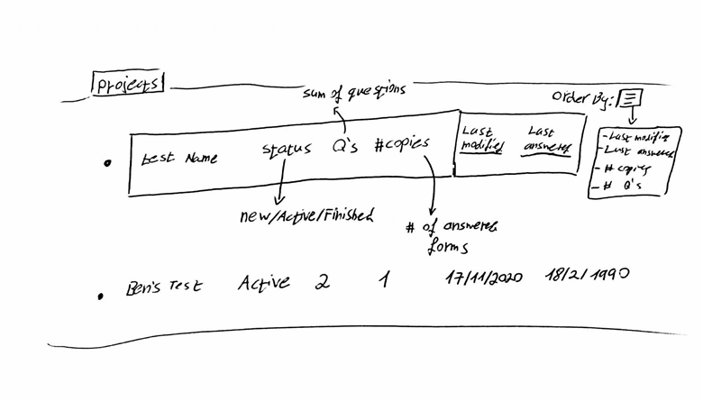

**The “blocks view” page:**

**Required features –**

· The user can collapse any block (the actual view of it’s data) at any given time.

· All of the projects blocks will be presented as a list.

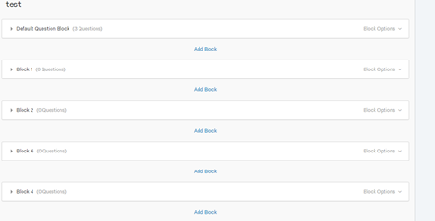

· Each block will have a visible list of questions objects.

· Each block will have a central button – “add a question”.

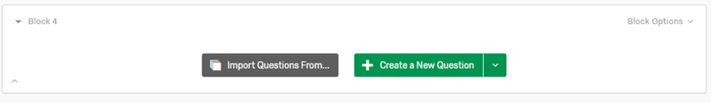

· Each block can be renamed.

· Each block will present the number of questions it contains.

**Required tools and mechanisms –**

· The ability to change a block’s position in the projects layout.

· Each block will have an options list that’ll contain:

- The ability to *save* a *block setting*.

- The ability to *save* a block’s *list of questions.*

- *Import* setting \ questions from a saved block.

- Move a block up\down in the project’s layout.

- Delete a block.

**Visual draft:**

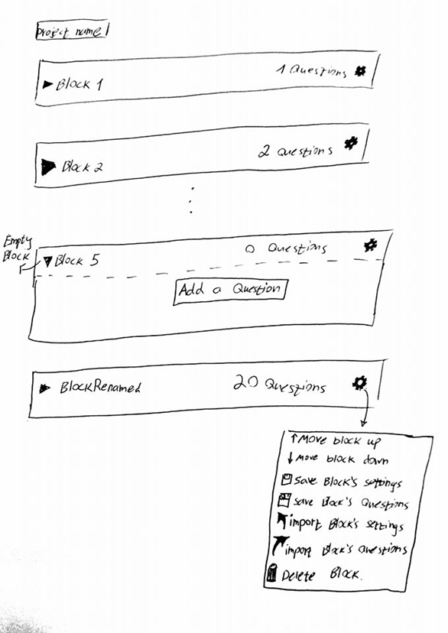

**The “Question unit” view:**

**Required features –**

· The user can change the question’s setting (detailed below) at any given time.

· Each text that need to be filled in a question will have a default “click to write question\answer” phrase.

· When a user clicks to edit the text of an answer or a question , it’ll update and immediately and undependably from other fields.

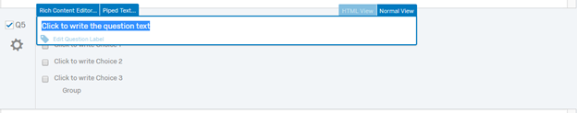

· Each question can be renamed (other than having an ordinal label).

· Each question will have the following “must have” settings:

- Question type.

- Question text position.

- Answers position.

- Allow time limit triggers.

Question type

The possible question’s types will be –

· Multiple choice question.

· Rating questions (choose the correct column by their description , “always” / “sometimes” etc’) .

· Free text question (provide a text box to be filled as an answer).

· Drill down questions (select the correct option from a menu that opens when’s clicked).

Each type should have it’s own options and limitations (a multiple choice should have an answer limit).

**Notice** that the question type also determines the kind of answers!

Question position

The position of the question’s text. We’ll allow the following:

· (a) Upper middle position (default).

· (b) Upper left corner.

· (c) Upper right corner.

· (d) Middle middle position.

· (e) Middle left position.

· (f) Middle right position.

· (g) Lower middle position.

· (h) Lower left corner.

· (i) Lower right corner.

Answers position

The position of the available answers.

- Multiple choice questions options:

- A vertical list (default).

-A horizontal list.

- A square matrix.

-Around the question (just for question position d ).

- Rating question: none.

- Free text questions:

All positions apart from the question’s position (a-i).

- Drill down questions: *same as multiple choice questions.*

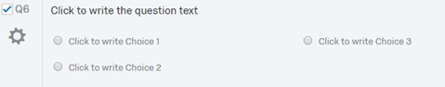

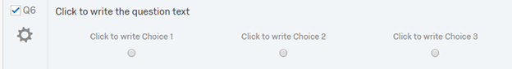

*Allow time limit triggers*

*When disabled – the user doesn’t have any time limitations.*

*When activated – the manager will be asked immidietly to enter the amount of time the subject will have, along with an option to enable a “clock trigger”. The clock will appear X seconds (also provided by the manager) on the subject’s screen before the time counter reaches zero.*

*The clock trigger will pop up at the upper left corner of the screen.*

***Required tools and mechanisms –***

*· Each question will provide the option to change it’s position in the block’s questions list.*

*· Each question will have a delete button.*

*· The user can add tags to a question. (might be used when filtering or searching).*

**Visual draft:**

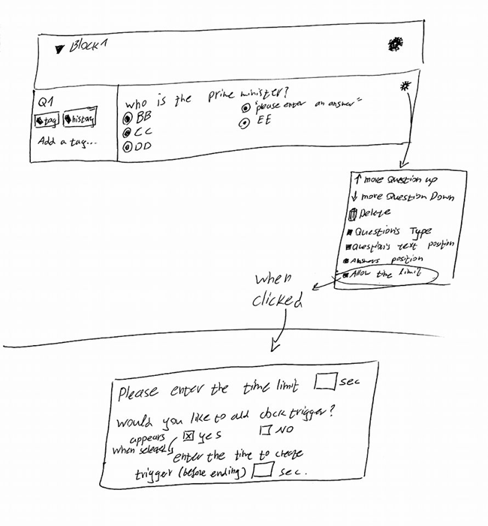

**The preview mode view**

**Required features –**

· The user should be able to play an authentic simulation on the survey, with the following exceptions:

- The user can exit the mode at any time.

- Data will NOT be collected and passed on to the analysis.

**The analysis view**

**Required features –**

· The analysis view will have a few different tabs-

- The “raw data” tab.

Raw data tab

The tab will present every answer and question as a listing , the columns for every entry will be:

· Question text.

· Selected answer (number and text).

· Block source.

· Date answered.

· Subject name and ID.

**Required tools and mechanisms –**

· The major mechanism should be the *filtering* mechanism , allowing the user to filter the raw data according to:

Date , question type , block , tags.

**Visual drafts:**

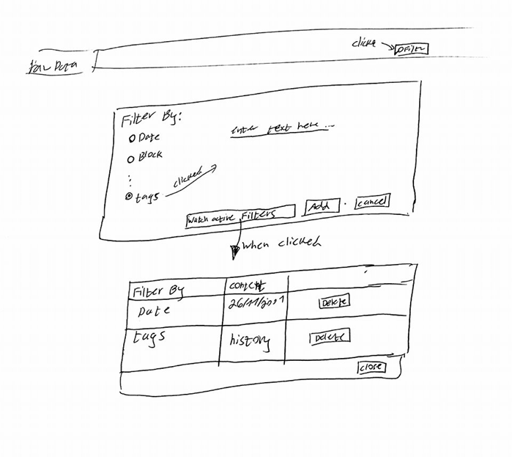

# References

# References for the backend technologies

# <https://blog.angular-university.io/developing-a-modern-java-8-web-app-with-spring-mvc-and-angularjs/>

# <https://spring.io/>

* <https://examples.javacodegeeks.com/enterprise-java/spring/mvc/angularjs-spring-integration-tutorial/>
* <https://www.journaldev.com/2882/hibernate-tutorial-for-beginners>
* <https://www.journaldev.com/3524/spring-hibernate-integration-example-tutorial>
* <https://www.journaldev.com/3531/spring-mvc-hibernate-mysql-integration-crud-example-tutorial>
* <http://hibernate.org/>
* <https://www.mysql.com/>
* <https://poweruphosting.com/blog/postgresql-vs-mysql-vs-sqlite/>
* <https://dev.mysql.com/doc/mysql-reslimits-excerpt/5.6/en/limits.html>
  1. **References for the frontend technologies**
* [https://stackoverflow.com/questions/12694530/what-is-typescriptand-why-would-i-use-it-in-place-of-javascript](https://stackoverflow.com/questions/12694530/what-is-typescript-and-why-would-i-use-it-in-place-of-javascript)

# References for the software implementation

* <https://developer.mozilla.org/en-US/docs/Web/API/Performance> - Performance API
* <https://jquery.com/> - what is jQuery?
* <https://www.w3schools.com/jquery/> advantages of jQuery
* <https://api.jquery.com/category/events/> - types of events
* <https://api.jquery.com/click/> - click event
* <https://api.jquery.com/category/events/event-object/> - The event object